User manuals

Intended for Public

Blueberry Pi

Everybyte Digital Products

**Table of Content**

Table of Content Page 1

Summary Page 2

Product Description Page 3

User instructions Page 4

Contact us Page 10

**Summary**

This user manual is provided for the users of DALTAMS, a Teaching Assistant (TA) Management System, that is currently accessible via our website at https://daltams.ca or https://daltams.000webhostapp.com. There are three types of users: Professor, Student, and TA. The user instruction on page 4 has the instruction for finding the navigation bar, and specific features that apply to each type of user. The product description on page 3 explains what DALTAMS is aimed to achieve, and what DALTAMS provide to our users.

**Product Description**

DALTAMS is a Teaching Assistant (TA) Management System that simplify the process of recruiting and managing TA. This web application can help students save time to apply for a TA position and managing their application; simplify the process for professor posting a job, tracking and evaluating TA; helping TA to managing their time schedule and submit the Hours of submission as well as seeing their performance. DALTAMS provides users with the user-friendly interface, easy to understand title, and straightforward interaction. The main focus for each type of user is the convenience, and timesaving. Another type of user that is integrated with our website is the Office side, which allows the human resource department to view and approve the hours of submission.

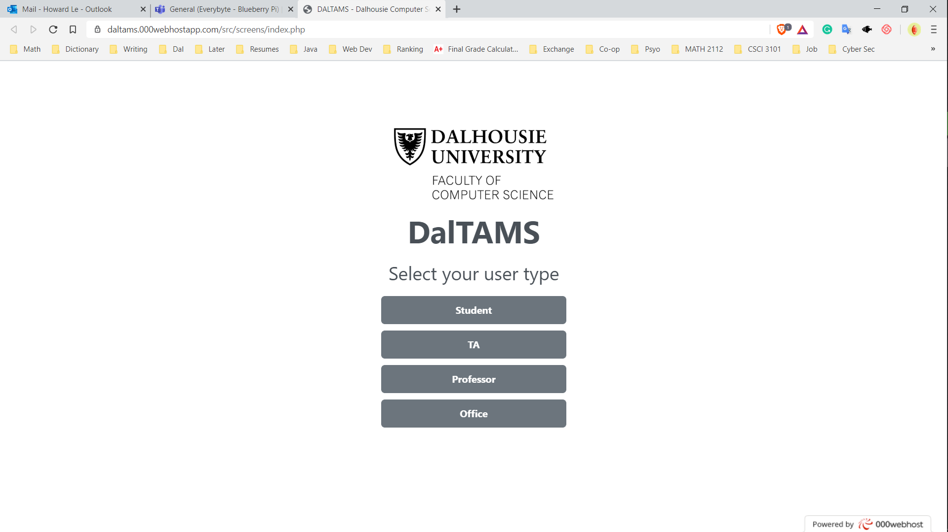

**User instructions**

In this section, there will be three sub-section for specific user including student, professor, and teaching assistant (TA). The user will select their role: Student, Professor, TA. Then, they will login with their NetID credentials to get access to the website. The navigation bar is located on the left of the website as a vertical bar. The picture below shows the location of the navigation bar.

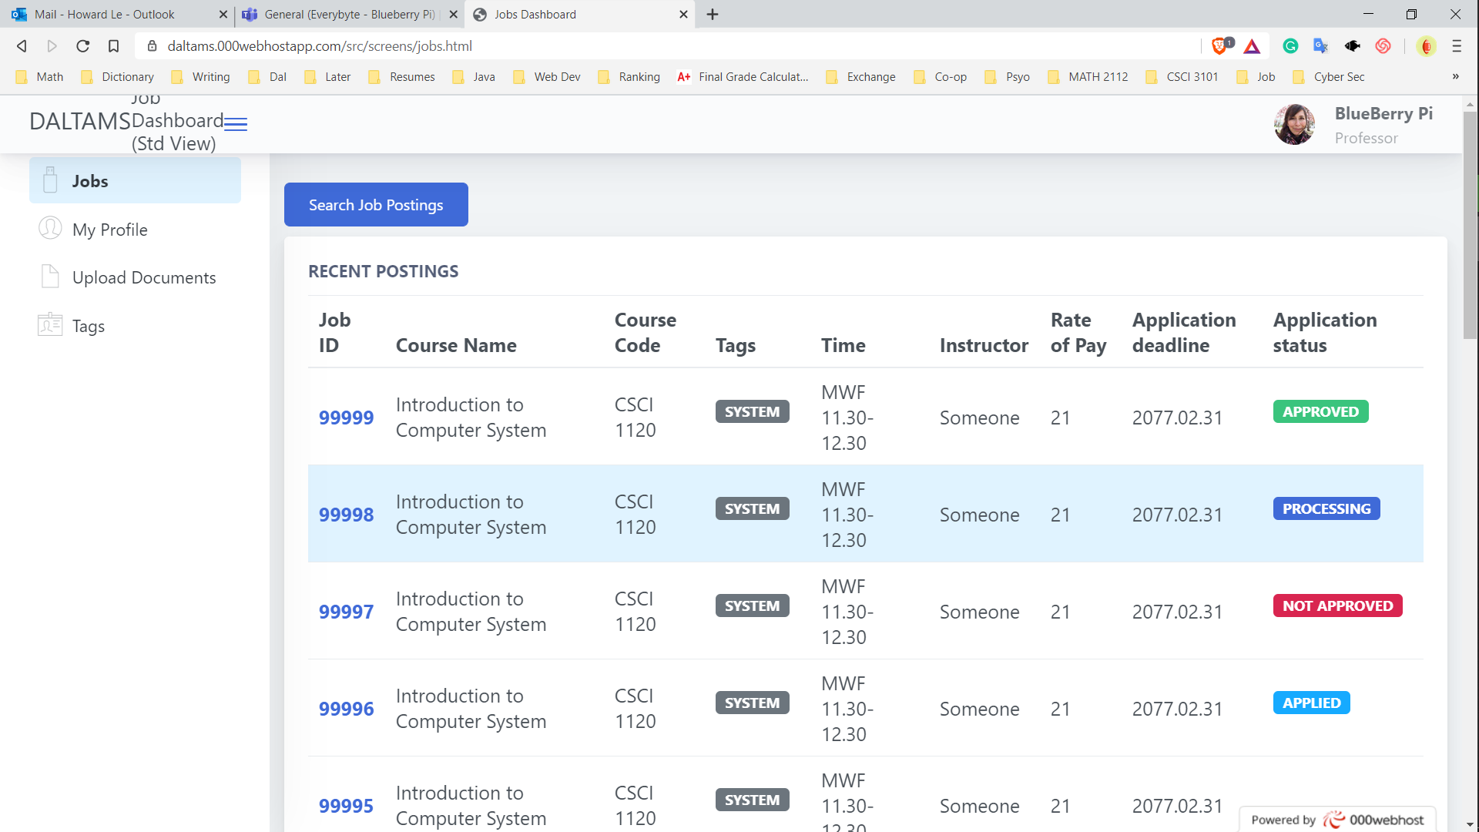

The location of the navigation bar.

Next, user will interact with the website as normal. The sub-section below will explain some features that some user may find it difficult to use.

1. **For Student:**

This sub-section will explain some useful features for student while using DALTAMS.

* Upload FUNCTION:

To upload a document, click the upload documents on the navigation bar, there will be a pop-up shown as below. The user will select the type of the file. The options are Resume, CV, Cover Letter, Academic Transcripts, or Timetable. Then the user clicks on choose file to select the file for upload. Only one file is allowed. After choosing the file, user clicks on upload to finish upload the documents. For multiple files, user do the same steps on each row.

The pop up for uploading documents.

* Tags:

The tags are used to quick search jobs that match specific tags. Below is the screenshot when the user clicks on the tag button on the navigation bar. When the pop-up shows, user click on the tag that they wish to see the jobs, and it will direct the user to the jobs with that tags.

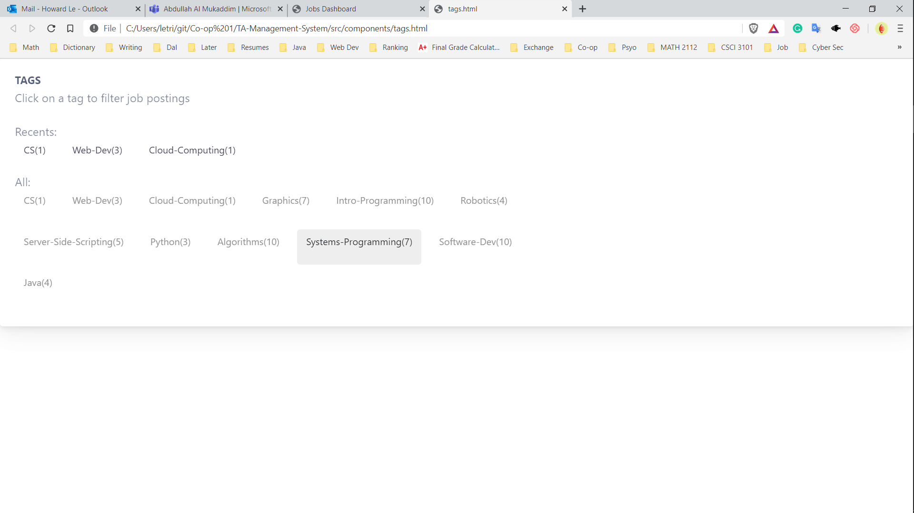

1. **For Professor:**

This sub-section will explain some notably features for professor while navigating DALTAMS.

* POST A JOB:

The picture below shows the location of the Post A New Job, the user will select a course as a dropbox, then click on draft. Then there will be a pop-up asks the user to fill in the job posting information and click submit in order to post the job to the job poll.

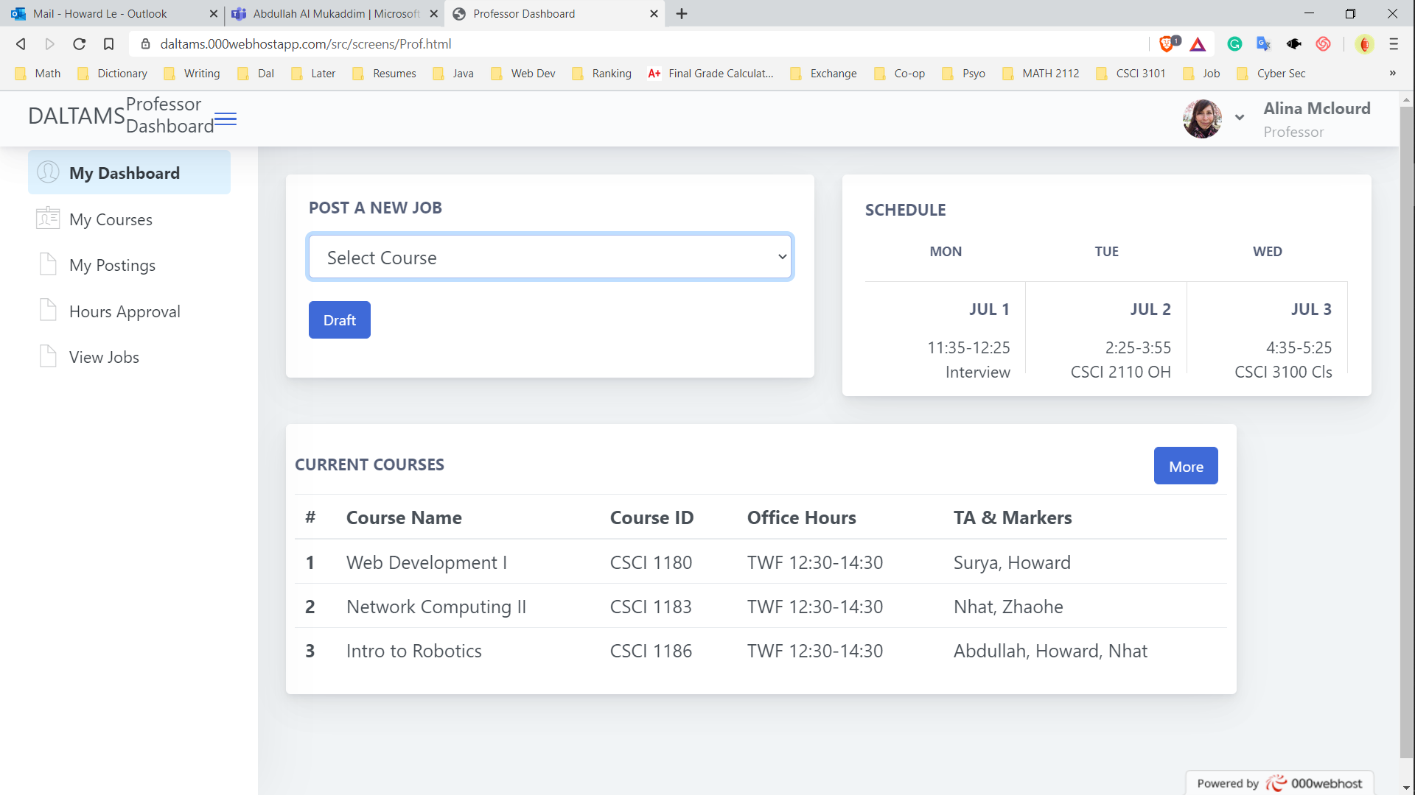

The location of the Post a New Job.

* VIEW HOURS OF APPROVAL:

To view, approve or decline an hour of approval, the user clicks on “hours approval” on the navigation bar. Then, there will be a list of TA’s hour of approval. The user clicks on the “VIEW” button on the right, next to the TA’s name, Banner ID to view the hours of approval in detail. The photo below shows the “VIEW” button location.

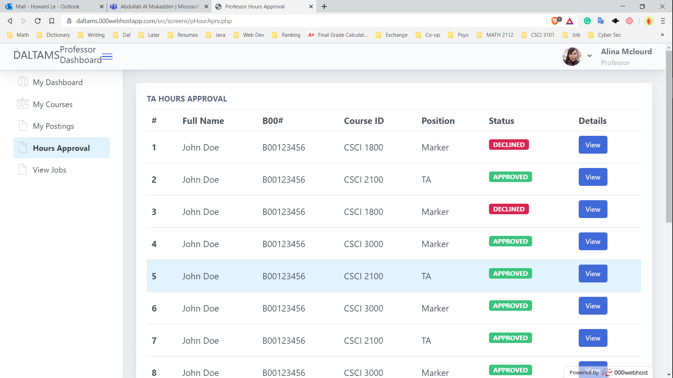

The location of the “VIEW” button

1. **For Teaching Assistant (TA):**

This sub-section will provide some useful features for Teaching Assistant using DALTAMS.

* SUBMIT HOUR OF SUBMISSION:

To submit the hour of submission, the user selects the course that they are teaching from the drop box, then click “Confirm selection”. Then, the user clicks “Proceed” to fill in the hours of submission. On click “Proceed”, the user will see a pop-up asking the information about the hours. The user will select the appropriate hours from the drop box and click “Submit” to send the hours of submission. The picture below shows the location of the hours of submission on the Dashboard.

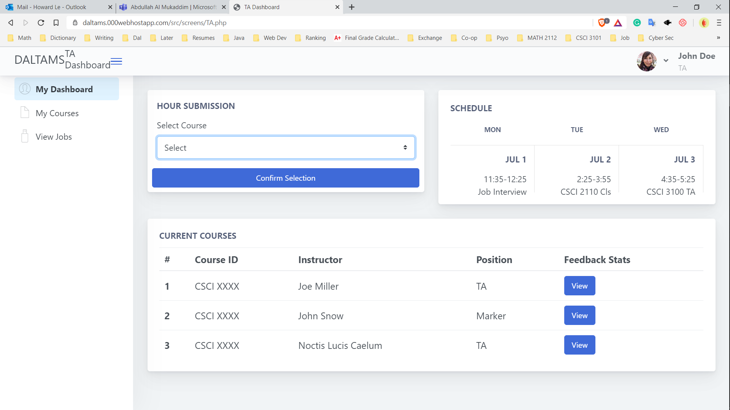

The location of the “VIEW” button

* VIEW STATISTICS AND PERFORMANCE:

To view the statistics for the performance in a course, the user clicks on “VIEW” button on the main dashboard. A pop-up appears and show the performance of the user in a course that they are teaching, evaluated by the professor of the course. Some statistics include teamwork, organization, time management, course knowledge, student engagement, and the comments from the professor (if available). The picture below shows the location of the “VIEW” button. To view the statistics from the past course, the user clicks on “My Courses” on the Navigation Bar.



The location of the “VIEW” button

**Contact us**

If you encounter any issues with the experience, functions, features on our website, you can contact us via the following ways:

* **Mail**: 123 Dalhousie Drive, Halifax, B3H 2T3, Nova Scotia, Canada.
* **Email:** feedback@daltams.ca
* **Phone call:** +1 (902)-111-2345
  + Monday to Friday: 8AM – 8PM (Atlantic Time)
  + Saturday and Sunday: 10AM – 5PM (Atlantic Time)